Parking Availability System

Design Plan Revision

Erik Meurrens, Benjamin Simonson, Ryan Jalloul, Evan Tobon, Samer Khatib

**Introduction**

**Purpose / Need**

Live parking data is only available at a select few locations on the University of Florida (UF) campus, making it difficult for those who must drive to campus to find parking during busy periods, as it is impossible to check real-time availability beforehand. The purpose of this project is to provide real-time, reliable and accessible parking capacity tracking information for individuals who wish to park at the parking facilities on campus. This information would be beneficial for off-campus commuters and visitors to campus, reducing the stress, frustration, and confusion drivers can feel trying to find parking, as well as the congestion that can occur at parking facilities, during busy traffic periods on campus. Our project, the Parking Availability System (PAS), was inspired to help the UF community, alleviating the symptoms of the lack of easily available parking resources for the campus and promoting quicker and more reliable transportation to and from campus, by offering a way to access parking availability information in real time via PAS.

**Domain & Prior Art**

Currently, there are existing implementations that provide onsite observability for garage capacities. The solution currently employed by the University of Florida is the Genetec AutoVu system that uses an automatic license plate recognition service to identify and read license plates and count vehicles that are currently in the facility. While effective in license plate identification, this solution lacks a virtual view of parking facility capacities and current availability. This omission inconveniences drivers searching for available parking when none exists. Additionally, the current system comes with a significant cost burden and is facilitated via subscription services that may go underutilized. Specifically, this system maintains a “$6000 servicing cost, $11,000-$8,000 per lane, and $2,495 per camera” [1]. In contrast, our project will provide a much more affordable solution to the AutoVu as it will only require equipment and installation fees. Our project will also provide virtual observability into parking facility current availability to streamline an individual's search into finding a parking spot.

**Impact & Risk Assessment**

This project will benefit the campus community by providing commuters and visitors with a mobile application to reference parking resources on campus and view real-time parking availability. This will have an overall benefit to campus by alleviating the current lack of easily accessible parking resources, thus reducing the stress, frustration, and confusion drivers feel trying to find parking on campus. Additionally, this would make it easier for drivers to plan their routes, promoting better traffic flow and less congestion on campus as drivers will know where they will be parking ahead of time. By lessening congestion and reducing the drivers’ frustration of finding parking, PAS will enable safer driving around campus, improving the safety of pedestrians and drivers alike.

However, one potential drawback, given that this system requires a video feed transmitted to an object detection model in the cloud, is concerns about personal privacy. While these parking facilities are public spaces, we guarantee that PAS will only collect video data in order to identify cars entering and exiting parking facilities and no more than what is necessary for no other purpose. With this in mind, we believe that the benefit to the community outweighs the privacy considerations.

**Statement of Work**

**Board Software**

A Raspberry Pi will handle object detection for vehicles, data streaming, and updating availability counter in the database. Equipped with a camera module, it will process a video stream at a minimum of 10 frames per second to detect vehicles and license plates. The Raspberry Pi will select an image frame with a high confidence containing the license plate, stream the data to AWS for license plate recognition. Cars are detected and determined to either be leaving or entering the facility, adjusting the counter accordingly.

The Raspberry Pi will use its Wi-Fi module to connect to the UF network, ensuring a connection to the internet to allow seamless data transfer to AWS for real-time updates. In the event of a lost connection, image frames will be cached until the connection is re-established. Additionally, allowing the board onto UF Wi-Fi would allow us to SSH into the board to program it live and remotely.

All the module initialization and usage will be established by programming the board using Python and will use the AWS IoT Core connectivity libraries.

**Object Detection Model**

Utilizing the preexisting You Only Look Once (YOLOv11) model by Ultralytics, we will make use of transfer learning to train the yolo11x model to specifically detect vehicles and license plates. This model will be run on the Raspberry Pi 3 to detect vehicles and send image snapshots to our dedicated remote processing servers to conduct the optical character recognition (OCR) using the Google Tesseract model and device registration within our databases through the Backend API.

The data used to train the transfer learning model will be trained on an open-sourced license plate dataset found on Hugging Face [2]. By using the pretrained YOLOv11 model and open-sourced dataset, we save extensive amounts of capacity in the project while maintaining a high level of accuracy in detection.

**Backend API**

Once the OCR model completes its recognition and has extracted the necessary data from the image sent from the Raspberry Pi 3, we register the information into a PostgreSQL database using a RESTful API written in Golang. The API implements CRUD functions to CREATE a new vehicle object stored in the database, READ a vehicle object that is stored in the database, UPDATE a new vehicle object as a replacement for an existing object in the database, and DELETE a vehicle object in the database.

Making use of a RESTful API to connect the detection pipeline to our frontend application standardizes what service to call to access data within the database. The frontend application will make use of the GET and DELETE functions within the API to update different pages with data from the database, and the detection pipeline will make use of the POST, PUT, and DELETE functions to add and update vehicles within the database, as well as deleting vehicles from the database once they exit the garage.

**Hardware Development**

* Our system is intended to maintain a persistent power source.
  + If no persistent source is available, the system is targeted to 24 hours.
    - We’re thinking two 10k mAh batteries would achieve this result when rotated every day gives us a total amount of power of about 40 hours, but this means constant maintenance.
  + Power over Ethernet was another option that needs to be considered but we are unsure of how this would work or if the power would be strong enough
* **Raspberry Pi**
  + **2.4-5GHz for wireless LAN capability and ~300 MB/s throughput.**

This allows the Raspberry Pi to connect to the internet or a local network for remote monitoring, sending data to a server, or triggering alerts. The throughput is sufficient for transferring image data, car counts, or other logs efficiently over a network.

* + **1.4Hz 64-bit quad-core processor, dual-band wireless LAN.**

The processing power is essential for handling the image processing algorithms, such as object detection and counting. It ensures that the Raspberry Pi can process video frames, detect cars, and count them in real-time.

* + - **Bluetooth 4.2**

You could use Bluetooth to connect to nearby devices, such as mobile phones or tablets, for monitoring car counts or other project-specific functionalities.

* + - **1 GB LPDDR2 SDRAM**

This memory may be sufficient for handling small to medium-sized image processing tasks, storing video frames temporarily, and running the car counting software alongside the operating system. Testing will happen to see if this is enough in the future.

* + - **4 USB 2.0 ports**

These ports can be used to connect peripherals, such as sensors or you could connect external storage for saving video recordings or logs.

* + - **HDMI**

The HDMI port allows you to connect a display for setting up, debugging, or visualizing the car detection and counting in real-time.

* + - **Camera Port**

This port connects directly to the camera module, such as the OV7670, which will be used to capture images or video of the garage entrance where the cars are being counted.

* + - **5V/2.5A DC power input**
* Camera Module
  + Raspberry Pi Camera Module v2

The 8 megapixel camera module should be enough to capture a good quality image under ideal lighting conditions and distance of a car’s license plate to perform autonomous license plate recognition. Unlike the OV7670 that was originally planned, this camera module has easily accessible libraries that would facilitate faster development of the proof-of-concept prototype.

* Microwave-Radar Sensor
  + The microwave-radar sensor can be used to enhance the accuracy of the car counting system by detecting when a vehicle is close to the entrance. This could trigger the camera to take images or help confirm a vehicle’s presence when counting.

All Together, these components allow for an efficient, low-cost solution for counting cars in a garage using image processing on a Raspberry Pi.

**Mobile Application**

A mobile application will be developed to provide an intuitive user interface, enabling users to search for parking facilities and view real-time availability. Built using the Flutter framework and Dart, the app will integrate the Google Maps API to display nearby parking facilities. Each facility will show its current availability, retrieved from an SQL database updated by an edge device at the garage. This approach ensures users can easily locate available parking in close proximity, streamlining the search process for parking spots.

**Core Features**

* Car object detection
* License plate recognition
* Video stream
* Wireless edge device
* Real-time Parking availability determination accessible via mobile app

**Secondary Features**

* Tracklog containing license plate information for cars that have entered and left
* Enforce legal parking in licensed zones

**Milestones and Tasks:**

|  |  |  |
| --- | --- | --- |
| **Pre-Alpha Build Milestone** | | **Target Date: 10/25/24** |
| **Features/Tasks:** | **Assignee(s):** | **Target Date:** |
| Identify and order remaining hardware modules to configure raspberry pi (RPi) | Ryan | 10/18/24 |
| Configure software backbone to RPi (OS, frameworks/libraries, programs) | Evan, Ben, Erik | 10/18/24 |
| Connect RPi to UF WiFi | Ben | 10/18/24 |
| Configure remote access to RPi for development | Erik | 10/18/24 |
| Connect camera module hardware to RPi | Ryan | 10/18/24 |
| View video feed from camera through RPi | Ben, Ryan | 10/25/24 |
| Configure AWS and SQL database | Samer | 10/18/24 |
| Complete Backend API | Samer | 11/15/24 |
| Establish connection from RPi to AWS and SQL database | Ben, Evan | 10/25/24 |
| Establish connection from App to SQL database | Ben, Erik | 10/25/24 |
| **Design Prototype Milestone** | | **Target Date:**  **11/22/24** |
| **Features/Task:** | **Assignee(s):** | **Target Date:** |
| View video stream on Raspberry Pi through hardwired connection | Evan | 11/03/24 |
| Configure EZ Park App to access SQL Database and LOT data | Erik | 11/03/24 |
| Provisional object detection model on RPi | Ben, Evan | 11/10/24 |
| Provisional ALPR model on AWS | Samer | 11/10/24 |
| Provisional Design and Printed Models for Hardware Housing | Ryan | 11/10/24 |
| Have EZ Park App retrieve “live” parking availability | Erik | 11/10/24 |
| Set up ALPR image frame transmission from RPi to AWS | Ben, Erik | 11/18/24 |
| View processed video stream from RPi remotely | Evan | 11/18/24 |
| Implement real-time parking counter in database | Erik, Evan | 11/18/24 |
| Test RPi object detection model performance | Ben | 11/21/24 |
| Test AWS ALPR model performance | Samer | 11/21/24 |
| Benchmark device prototype | Ryan | 11/21/24 |
|  |  |  |
| **Alpha Build & Test Plan** | | **Target Date:**  **~01/31/25** |
| **Features/Task:** | **Assignee(s):** | **Target Date** |
| Provisional object detection model that requires some tuning | Ben, Erik |  |
| Provisional AWS ALPR model that requires some tuning | Samer, Evan |  |
| Ultra-sonic sensor set-up and tuning to “wake-up” RPi upon possible vehicle detection | Ryan |  |
| **Beta Build & Test Plan, Alpha Results** | | **Target Date:**  **~02/21/25** |
| **Feature/Task:** | **Assignee(s):** | **Target Date:** |
| Identify point of contact to setup module in Reitz parking facility and begin the installation process | All |  |
| Monitor module performance in Reitz facility and tune object detection and AWS ALPR models’ | Samer, Ben, Evan |  |
| **Release Candidate** | | **Target Date:**  **~03/21/25** |
| **Feature/Task:** | **Assignee(s):** | **Target Date:** |
| Proof-of-concept model that functions within a concentrated time frame | All |  |
| **Production Release** | | **Target Date:**  **~04/11/25** |
| **Feature/Task** | **Assignee(s):** | **Target Date:** |
| Fully functioning object detection model with accurate results | Ben, Erik |  |
| Fully functioning machine learning model with accurate results | Evan, Samer |  |
| Viewable livestream to confirm car detection accuracy during a live demonstration | All |  |

**Deliverable Artifacts**

Hardware Module: Raspberry Pi, Camera, and Physical Housing

* The board and attachments will facilitate the capture and the transmission of necessary data. This data will consist of capturing the car and license plate frames, transmitting car and license plate frames, and benchmarking car entry via a sensor. The frames will be transmitted by the board to the AWS module for further feature extraction and analysis.
* Maintenance will depend on whether the module has persistent power supply, and the lifespan of the attached components will depend on usage. Assuming no persistent power supply, batteries will need to be changed and recharged every 24 hours.

Yolov11 Car Detection Model

* This model will oversee detecting and sending the information regarding the detection of a car from the Hardware Module to the AWS Module for further processing. This model will be run entirely on the Raspberry Pi and will be the first step in the pipeline of registering a new car entering the garage or removing a car that has just exited the garage.
* No maintenance will need to be done once the model is properly finetuned and trained on a specific dataset to detect only cars and license plates.

Backend API

* This backend API will be a RESTful API that acts as a middleman between the frontend Parking Availability Application and the Hardware Module. By implementing CREATE, READ, UPDATE, and DELETE (CRUD) functions, the API will allow access to the PostgreSQL Database without having to directly write or read from it.
* Minimal maintenance will be needed once the API is completed, as the only changes required will be potential updates and changes to the functions as the scope of the project changes.

AWS Module

* The AWS module will receive the frame binary data from the board and build an image from it. The model will then confirm that a vehicle has been detected and has entered or exited the parking facility. Optical Character Recognition will be run to identify the characters of the license plate and assign it to that vehicle. If a vehicle enters or exits the facility a global counter will be incremented or decremented respectively which will convey the total number of vehicles in the facility. The license plate will be assigned to the vehicle that has entered the facility and removed when the vehicle exits the facility.
* Maintenance will include observing costs accrued by different AWS services and apply changes to ensure that the model is maintaining its performance at the minimal potential financial impact.

PostgreSQL Database

* This database will be accessible by both the AWS module and the board through the backend API. The board will write the benchmark entry data of cars to this database and the AWS module will assign the interpreted license plate to the car that has entered the parking facility.
* No maintenance will need to be done besides cleaning left over data, if any, and validating the performance of the model and the sensor as need be.

Parking Availability Application

* This application will be developed to allow users to enhance observations in facility availability. It will allow users to search for different parking facilities on campus to observe available parking options on campus.
* Maintenance will include ensuring that the application is available to mobile user markets, ensuring that identified bugs are resolved in a timely manner, and that recommended enhancements to the application are considered and enacted.

Programming Interface Repository

* This deliverable will contain all the source code for all the artifacts. It will maintain a concurrent instance of all aspects of this project.
* Maintenance will include ensuring that the most up to date version of all code is pushed and available to this repository. It might also include issues of any known problems or bugs, and any ideas that are planned to be enacted upon.

**Accessibility, Usability, and Maintenance**

A goal of PAS is to make a low-cost alternative to current modern smart parking systems on the market. By achieving this goal, we expect to greatly increase accessibility to smart parking systems by significantly reducing the costs of installation and maintenance of such systems in parking facilities, allowing for existing and new parking facilities to easily adopt our system. Additionally, the plan is to have the system be scalable to all parking facilities by configuring the camera devices to be assigned to specific facilities, so long as those facilities are configured in a database, tracking in-flow and out-flow according to their respective facilities. As long as the cameras are mounted properly at the entry/exit lanes of the facility, they will be able to count availability within the facility.

These devices within parking facilities will be connected to a remote database to update parking availability within these facilities in real-time. Another goal of PAS is making this information readily available to drivers so that they can use it to inform their parking decisions in advance or in the moment. For this reason, to make PAS available and its information usable for drivers, a mobile application will be used as the primary means by which this information will be conveyed. Because 96% of the U.S. population has access to a smartphone [3], and likely carry it with them when leaving their homes, this ensures that almost every person should have access to this information at all times in a portable form, supposing they are aware of the app’s existence.

Currently, the long-term maintenance plan for PAS involves updating the database based on new parking facility developments on campus, periodically SSH-ing into the camera devices to check camera status, and outreach to ensure people are aware of the system so that we can maximize the benefit of having such a system on campus. Additionally, by checking the camera device status by SSH-ing, if a connection is unable to be established, this would need to be physically checked by a person in order to identify what went wrong, for example, if the camera lost power, if the camera lost its WiFi connection, if the software crashed, if the physical hardware was damaged, or if the device was stolen.

**Mockups**

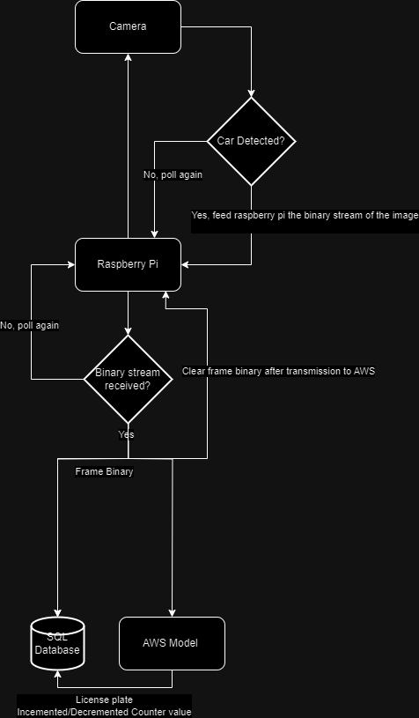

**Figure 1.** System Architecture Diagram

**Figure 2.** Board Program Flowchart

**Figure 3.** Mobile App High-Fidelity Wireframes

**Figure 4.** Mobile App User Flow Diagram

**Figure 5.** System Networking Diagram

**Figure 6.** Plan to Validate System Performance Using Sensor

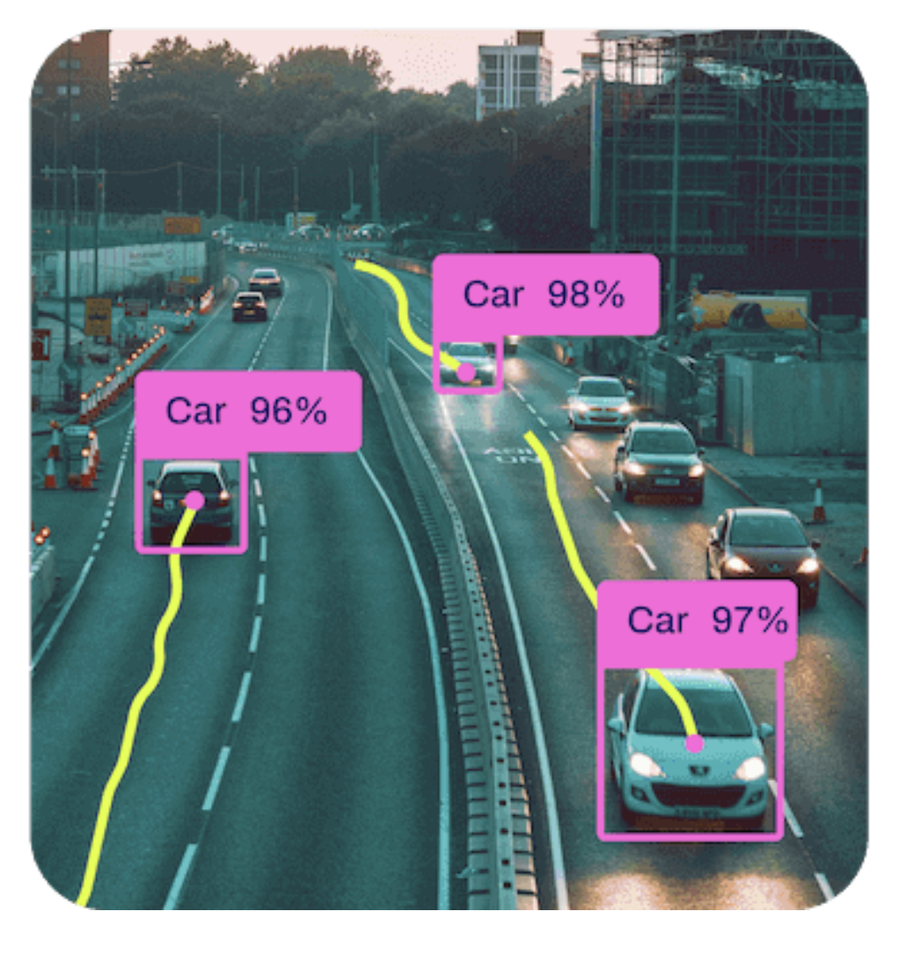

**Figure 7.** YOLOv11x model detecting vehicles

**References**

[1]L. Du and S. Washburn, “SMART PARKING SYSTEM ON UF CAMPUS,” Apr. 2019. Available: <https://fora.aa.ufl.edu/docs/38/2018-2019/SmartParkingProposalLiliDuScottWashburn.pdf>

[2] A. Startups, ‘Vehicle Registration Plates Dataset’, *Roboflow Universe*. Roboflow, Jun-2022.

[3] F. Laricchia, "Smartphones in the U.S. - statistics & facts," 14 June 2024. [Online]. Available: https://www.statista.com/topics/2711/us-smartphone-market/#topicOverview. [Accessed 1 November 2024].